Go here

<https://www.onboarddenmark.dk/app/public-tools/cultural-thumbprint/>

When you click to CREATE THUMBPRINT

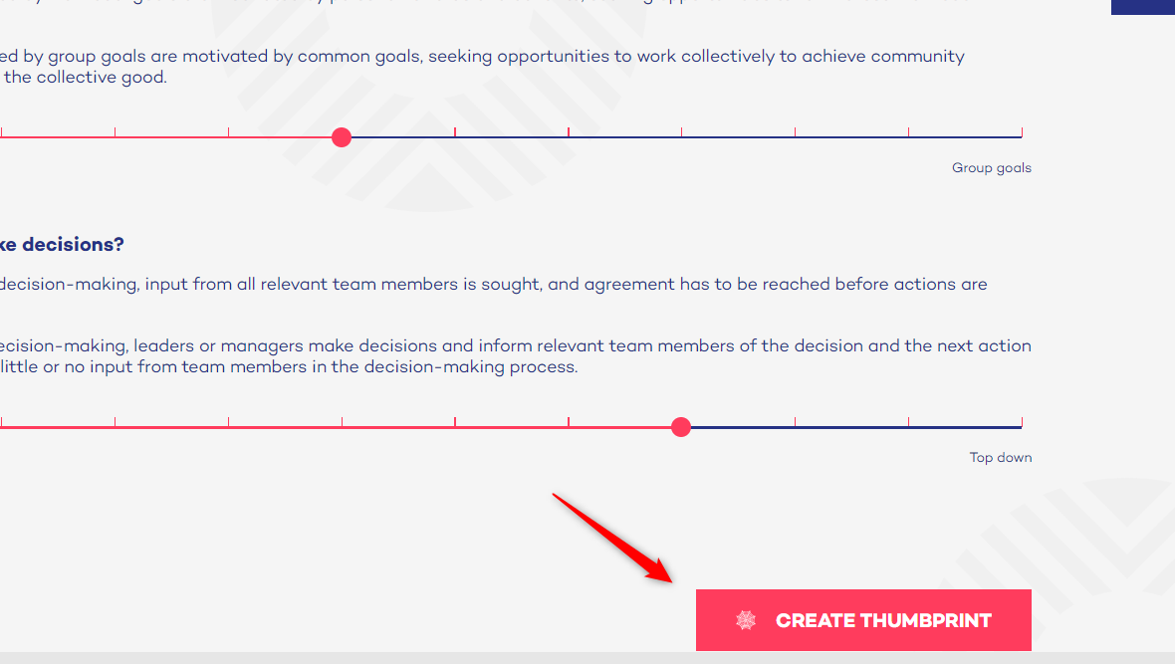

Then this is produced

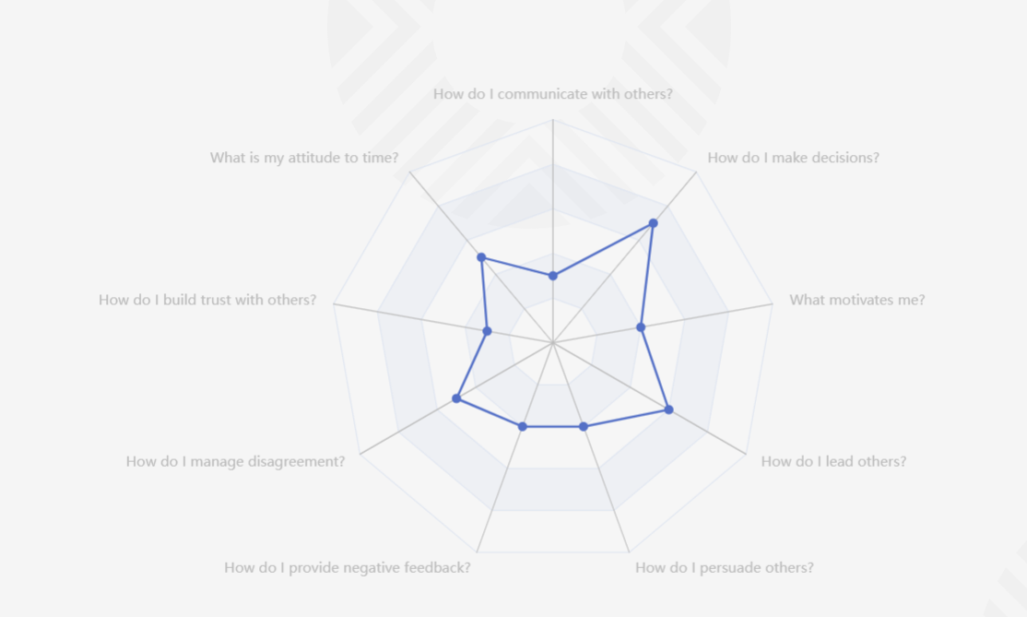

However, labels are missing!!! We need something like this:

Each line should have the labels like this

